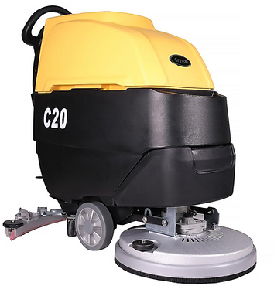

ELECTRIC CABINET ASSEMBLY
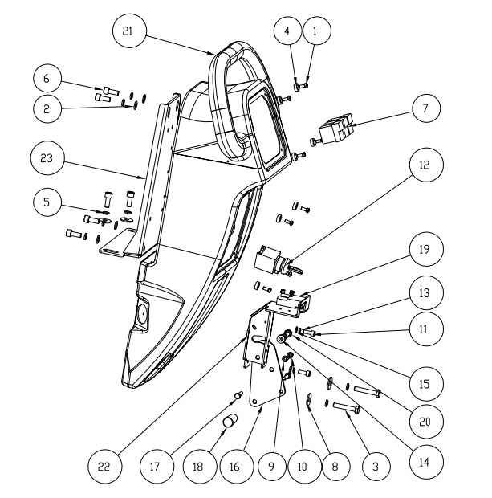
NO. | Part number | Name | Description | Quantity
1 | G010123 | 盘头十字螺钉M5*12 不锈钢 | Stainless steel pan head cross screw M5*12 | 8
2 | G010177 | 平垫圈Φ8*Φ16*1.5 不锈钢 | Flat washer stainless steelΦ8*Φ16*1.5 | 5
3 | G010156 | m8*40外六角螺丝 | External hexagonal screw m8*40 | 2
4 | B010184 | 塑料平垫 | Plastic flat pad | 8
5 | G010170 | 弹垫M8 不锈钢 | stainless steel spring washer M8 | 9
6 | G010134 | 内六角圆柱头螺钉M8*20 不锈钢 | stainless steel hexagon socket cylindrical head screws M8*20 | 6
7 | E010132 | 翘板开关 | Rocker switch | 3
8 | G010178 | 平垫圈Φ8*Φ24*2 不锈钢 | Flat washer stainless steelΦ8*Φ24*2 | 4
9 | G010100 | 螺母M6 不锈钢 | stainless steel nut M6 | 1
10 | G010106 | 自锁螺母M6 不锈钢 | stainless steel hexagon socket cylindrical head screws M6 | 1
11 | G010131 | 内六角圆柱头螺钉M6*16 不锈钢 | stainless steel hexagon socket cylindrical head screws M6*16 | 2
12 | E010134 | 钥匙开关 | Key switch | 1
13 | G010169 | 弹垫M6 不锈钢 | stainless steel spring washer M6 | 2
14 | C010121 | 铜套 Φ8xΦ12x4 | Copper sleeveΦ8xΦ12x4 | 1
15 | G010175 | 平垫圈Φ6*Φ12*1 不锈钢 | Flat washer stainless steelΦ6*Φ12*1 | 2
16 | A010103 | 扒头提升摇臂 | Head lifting rocker arm | 1
17 | G010151 | 外六角M6*25 不锈钢 | Stainless steel outer hexagon M6*25 | 2
18 | B010193 | 胶木手柄 M8X40 | Bakelite handle M8X40 | 1
19 | E010135 | 安德森插头 | Anderson plug | 1
20 | G010152 | 外六角M8*20 不锈钢 | Stainless steel outer hexagon M8*20 | 1
21 | B010103 | 控制箱 530 | Control box 530 | 1
22 | A010116 | 摇臂支架 | Rocker arm bracket | 1
23 | A010113 | 清水箱支架 | Clean water tank bracket | 1
RECOVERY TANK ASSEMBLY
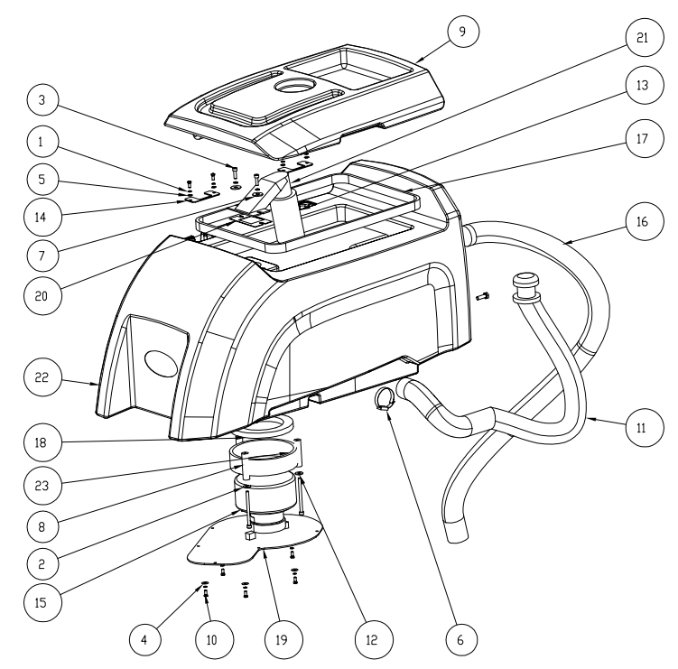

NO. | Part number | Name | Description | Quantity
1 | G010168 | 弹垫M5 不锈钢 | spring washer M5 | 9
2 | G010182 | 平垫圈Φ6*18*1.5 不锈钢 | stainless steel plain washersΦ6*18*1.5 | 3
3 | G010131 | 内六角圆柱头螺钉M6*16 不锈钢 | stainless steel hexagon socket cylindrical head screws M6*16 | 2
4 | G010174 | 平垫圈Φ5*Φ15*1.5 不锈钢 | stainless steel plain washersΦ5*Φ15*1.5 | 5
5 | G010172 | 平垫圈Φ5*Φ10*1 不锈钢 | stainless steel plain washersΦ5*Φ10*1 | 4
6 | G010198 | 不锈钢喉箍 Φ27-51 | Stainless steel pipe clampΦ27-51 | 1
7 | G010178 | 平垫圈Φ8*Φ24*2 不锈钢 | stainless steel plain washersΦ8*Φ24*2 | 2
8 | B010182 | PU棒Φ6XΦ16X65 | PU rodΦ6XΦ16X65 | 3
9 | B010102 | 污水箱盖 530 | Sewage tank cover 530 | 1
10 | G010123 | 盘头十字螺钉M5*12 不锈钢 | Stainless steel pan head cross screw M5*12 | 5
11 | B010141 | 排污管 Φ38x780（01+09） | Sewage pipeΦ38x780（01+09） | 1
12 |  | M5-20内六角螺丝 | Hexagon socket screw M5-20 | 4
13 | G010169 | 弹垫M6 不锈钢 | Stainless steel spring pad M6 | 5
14 | B010153 | 吸污口过滤网 | Suction port filter screen | 1
15 | A010115 | 污水箱盖连接件 | Sewage tank cover connector | 2
16 | E010109 | 吸水电机 24V 500W 两层旁管出风 | Two-layer side pipe air outlet and suction motor 24V 500W | 1
17 | B010142 | 吸污管 | Sewage suction pipe | 1
18 | B010178 | 污水箱密封条 | Sewage tank sealing strip | 1
19 | B010175 | 吸水电机密封圈 Φ145*Φ90*11 | Sealing ring of suction motorΦ145*Φ90*11 | 1
20 | A010114 | 吸水电机盖板 | Cover plate of suction motor | 1
21 | B010152 | 吸污口密封垫 | Sealing gasket of dirt suction port | 1
22 | B010151 | 吸污口主体 | Main body of suction port | 1
23 | B010101 | 污水箱 530 | bilge tank 530 | 1
24 | B010176 | 吸水电机消音棉 650*100 | Absorbent motor silencing cotton 650*100 | 1

SOLUTION TANK ASSEMBLY
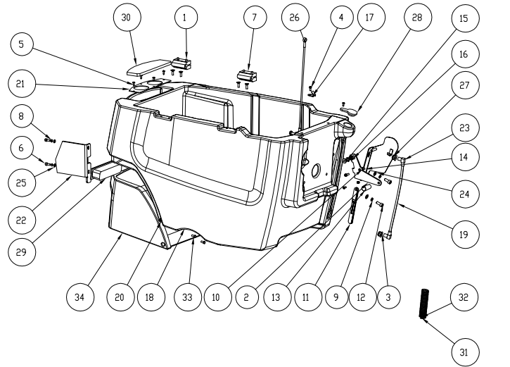
NO. | Part number | Name | Description | Quantity
1 | G010113 | 沉头内六角M6*16 不锈钢 | Stainless steel countersunk head hexagonal socket M6*16 | 8
2 | A010119 | 压力支架摇臂 | Pressure support rocker arm | 1
3 | B010183 | 水位密封圈 | Water level seal ring | 2
4 | G010123 | 盘头十字螺钉M5*12 不锈钢 | Stainless steel pan head cross screw M5*12 | 6
5 | G010122 | 十字槽盘头自攻螺丝 | Cross recessed pan head tapping screw | 5
6 | G010131 | 内六角圆柱头螺钉M6*16 不锈钢 | stainless steel hexagon socket cylindrical head screws M6*16 | 3
7 | B010181 | 塑料合页 65X65 | Plastic hinge 65X65 | 2
8 | G010169 | 弹垫M6 不锈钢 | Stainless steel spring pad M6 | 2
9 | G010170 | 弹垫M8 不锈钢 | Stainless steel spring pad M8 | 2
10 | G010106 | 自锁螺母M6 不锈钢 | stainless steel hexagon socket cylindrical head screws M6 | 1
11 | A010118 | 压力支架连杆 | Pressure bracket connecting rod | 2
12 | G010134 | 内六角圆柱头螺钉M8*20 不锈钢 | stainless steel hexagon socket cylindrical head screws M8*20 | 2
13 | B010193 | 胶木手柄 M8X40 | Bakelite handle M8X40 | 1
14 | C010120 | 铜套 Φ6xΦ10x6 | Copper sleeveΦ6xΦ10x6 | 1
15 | C010124 | 铜套 | Copper sleeve | 1
16 | G010107 | 自锁螺母M8 不锈钢 | stainless steel hexagon socket cylindrical head screws M8 | 1
17 | A010121 | 排污管挂钩 | Sewage pipe hook | 1
18 | B010100 | 清水箱 530 | Clean water tank 530 | 1
19 |  | 水位显示管Φ12*300mm | Water level display tube Φ12*300mm | 1
20 | G010172 | 平垫圈Φ5*Φ10*1 不锈钢 | stainless steel plain washersΦ5*Φ10*1 | 3
21 | A010120 | 注水口钣金 | Water filler sheet metal | 1
22 | A010207 | 机头清水箱支架（双刷） | Head clean water tank bracket （double brush） | 1
23 | B010191 | 塑料弯头 | Plastic Elbows | 2
24 | G010177 | 平垫圈Φ8*Φ16*1.5 不锈钢 | stainless steel plain washersΦ8*Φ16*1.5 | 3
25 | G010175 | 平垫圈Φ6*Φ12*1 不锈钢 | stainless steel plain washersΦ6*Φ12*1 | 2
26 | C010129 | 水箱拉线 350 | Water tank cable 350 | 1
27 | A010117 | 压力支架 | Pressure support | 1
28 | B010149 | 加水口橡胶盖 | Rubber cover of water filler | 1
29 | E010144 | 长条灯 24V | Strip lamp 24V | 1
30 | B010150 | 小加水口盖 | Small filler cap | 1
31 | C010140 | 压簧 Φ2XΦ17X22 | Compression springΦ2XΦ17X22 | 1
32 | C010139 | 拉簧 Φ3XΦ25X170X115 | draw springΦ3XΦ25X170X115 | 1
33 | G010150 | 外六角M6*12 不锈钢 | Stainless steel outer hexagon M6*12 | 2
34 | B010104 | 电机罩 530 | Motor cover 530 | 1

NOSE ASSEMBLY
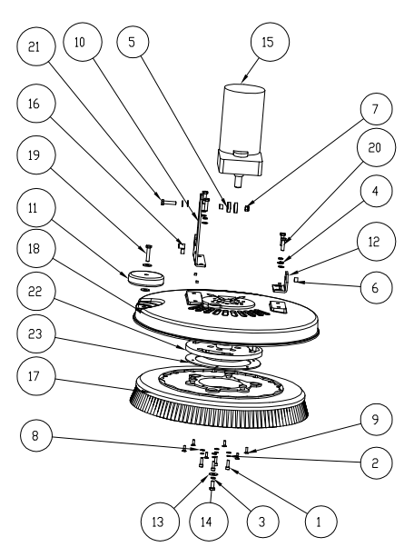
NO. | Part number | Name | Description | Quantity
1 | G010131 | 内六角圆柱头螺钉M6*16 不锈钢 | Stainless steel hexagon socket head cap screw M6*16 | 4
2 | G010169 | 弹垫M6 不锈钢 | Stainless steel spring pad M6 | 4
3 | G010170 | 弹垫M8 不锈钢 | Stainless steel spring pad M8 | 5
4 | G010177 | 平垫圈Φ8*Φ16*1.5 不锈钢 | Flat washer stainless steelΦ8*Φ16*1.5 | 6
5 | G010192 | 轴承 6001 ZZ | Bearing 6001 ZZ | 2
6 | C010122 | 铜套 Φ8xΦ12x9 | Copper sleeveΦ8xΦ12x9 | 3
7 | G010107 | 自锁螺母M8 不锈钢 | Stainless steel self-locking nut M8 | 1
8 | G010175 | 平垫圈Φ6*Φ12*1 不锈钢 | Flat washer stainless steelΦ6*Φ12*1 | 4
9 | G010113 | 沉头内六角M6*16 不锈钢 | Stainless steel countersunk head hexagonal socket M6*16 | 6
10 | A010109 | 机头支架 | Head bracket | 1
11 | B010196 | 防撞轮 Φ80*25 | Anti-collision wheelΦ80*25 | 1
12 | A010110 | 机头支架 | Head bracket | 1
13 | G010178 | 平垫圈Φ8*Φ24*2 不锈钢 | Flat washer stainless steelΦ8*Φ24*2 | 3
14 | G010152 | 外六角M8*20 不锈钢 | Stainless steel outer hexagon M8*20 | 1
15 | E010100 | 刷盘电机 220V 550W Φ18 | Brush disc motor 220V 550W Φ18 | 1
16 | C010123 | 铜套 Φ8xΦ12x17 | Copper sleeveΦ8xΦ12x17 | 1
17 | B010125 | 刷盘 | Brush disc | 1
18 | C010146 | 铸铝刷盘罩 530 | Cast aluminum brush disc cover | 1
19 | G010156 | M8-40外六角螺丝 | External hexagonal screw M8-40 | 1
20 | G010154 | 外六角M8*30 不锈钢 | Stainless steel outer hexagon M8*30 | 4
21 | G010155 | 外六角M8*35 不锈钢 | Stainless steel outer hexagon M8*35 | 1
22 | C010134 | 销钉刷盘扣 | Pin brush buckle | 1
23 | A010104 | 磁吸刷盘片 | Magnetic brush disc | 1
FRAME ASSEMBLY
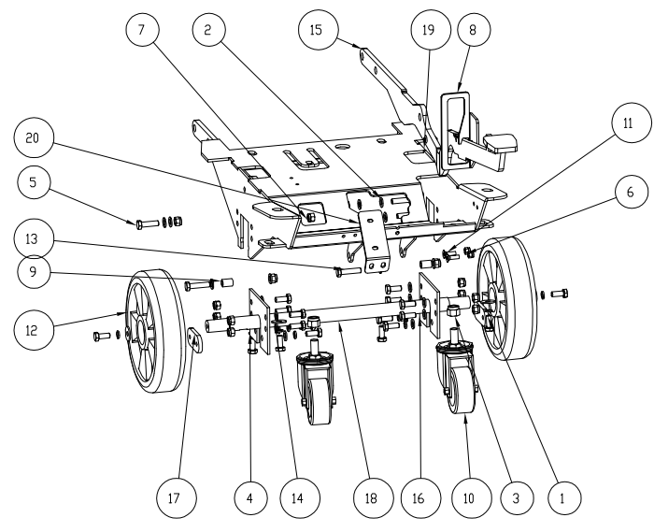
NO. | Part number | Name | Description | Quantity
1 | G010152 | 外六角M8*20 不锈钢 | Stainless steel outer hexagon M8*20 | 18
2 | G010177 | 平垫圈Φ8*Φ16*1.5 不锈钢 | stainless steel plain washersΦ8*Φ16*1.5 | 22
3 | G010109 | 自锁螺母M12 不锈钢 | Stainless steel self-locking nut M12 | 2
4 | G010170 | 弹垫M8 不锈钢 | Stainless steel spring pad M8 | 10
5 | G010154 | 外六角M8*30 不锈钢 | Stainless steel outer hexagon M8*30 | 3
6 | G010106 | 自锁螺母M6 不锈钢 | Stainless steel self-locking nut M6 | 2
7 | G010107 | 自锁螺母M8 不锈钢 | Stainless steel self-locking nut M8 | 13
8 | A010111 | 踏板支架 | Pedal bracket | 1
9 | C010123 | 铜套 Φ8xΦ12x17 | Copper sleeveΦ8xΦ12x17 | 2
10 | B010161 | 万向轮 3寸 | Universal wheel 3 inches | 2
11 | G010113 | 沉头内六角M6*16 不锈钢 | Stainless steel countersunk head hexagonal socket M6*16 | 2
12 | B010155 | 轴承轮 Φ200x50 | Bearing wheelΦ200x50 | 2
13 | G010155 | 外六角M8*35 不锈钢 | Stainless steel outer hexagon M8*35 | 2
14 | G010178 | 平垫圈Φ8*Φ24*2 不锈钢 | Flat washer stainless steelΦ8*Φ24*2 | 6
15 | A010108 | 机头提升支架 | Head lifting bracket | 1
16 | A010123 | 轮轴限位板 | Axle limit plate | 2
17 | A010122 | 轮轴固定板 | Wheel axle fixing plate | 2
18 | C010100 | 脚轮连接轴 | Castor connecting shaft | 1
19 | A010105 | 底座架 530 | Base frame 530 | 1
20 | A010112 | 过滤器支架 | Filter holder | 1

SUPPORT FRAME ASSEMBLY
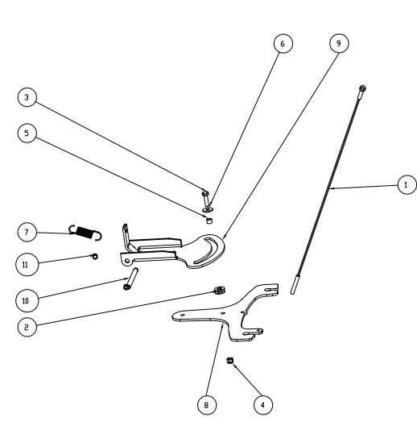
NO. | Part number | Name | Description | Quantity
1 | A010101 | 扒头上支架 | Upper bracket of the head | 1
2 | C010128 | 吸扒拉线 490 | Suction cable 490 | 1
3 | G010167 | 外卡簧Φ9 不锈钢 | Stainless steel outer circlipΦ9 | 2
4 | C010101 | 吸扒连接轴 | Suction connecting shaft | 1
5 | C010138 | 拉簧 Φ2.8XΦ20X109 | draw springΦ2.8XΦ20X109 | 1
6 | C010122 | 铜套 Φ8xΦ12x9 | Copper sleeve Φ8xΦ12x9 | 2
7 | B010206 | 尼龙垫片 Φ12xΦ24x2.0 | Nylon gasketΦ12xΦ24x2.0 | 4
8 | G010178 | 平垫圈Φ8*Φ24*2 不锈钢 | Flat washer stainless steelΦ8*Φ24*2 | 2
9 | G010154 | 外六角M8*30 不锈钢 | Stainless steel outer hexagon M8*30 | 2
10 | G010107 | 自锁螺母M8 不锈钢 | Stainless steel self-locking nut M8 | 2
11 | A010102 | 扒头下支架 | Lower bracket | 1
12 | G010101 | 螺母M8 不锈钢 | Stainless steel nut M8 | 1
SQUEEGEE ASSEMBLY
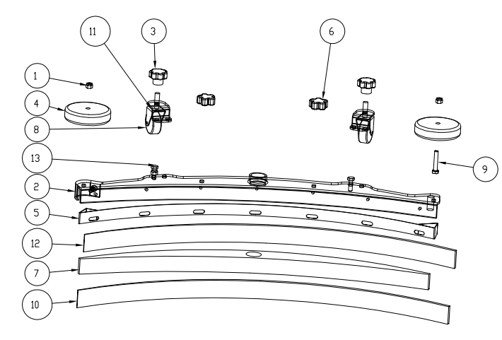
NO. | Part number | Name | Description | Quantity
1 | G010107 | 自锁螺母M8 不锈钢 | Stainless steel self-locking nut M8 | 3
2 | C010149 | 扒头主体800 | Head removal main body 800 | 1
3 | B010195 | 胶木十字手柄 M10 | Bakelite cross handle M10 | 2
4 | B010196 | 防撞轮 Φ80*25 | Anti-collision wheelΦ80*25 | 2
5 | A010214 | 吸扒钢条 800 | Suction steel bar 800 | 1
6 | B010194 | 胶木十字手柄 M8 | Bakelite cross handle M8 | 2
7 | B010222 | 胶条压板 800 | Adhesive strip pressing plate 800 | 1
8 | B010220 | 万向轮 2寸丝杆 M10*40 | Universal wheel 2-inch screw rod M10*40 | 2
9 |  | 外六角半牙M8*65不锈钢 | Stainless steel outer hexagon half tooth M8*65 | 1
10 | B010185 | 前胶条 52*844 | Front rubber strip 52*844 | 1
11 | A010215 | 吸扒万向轮支架 | Pick-up universal wheel bracket | 2
12 | B010186 | 后胶条 51*895 | Rear rubber strip 51*895 | 1
13 | G010154 | 外六角M8*30 不锈钢 | Stainless steel outer hexagon M8*30 | 2

