一SCHEMATIC DRAWINGS一

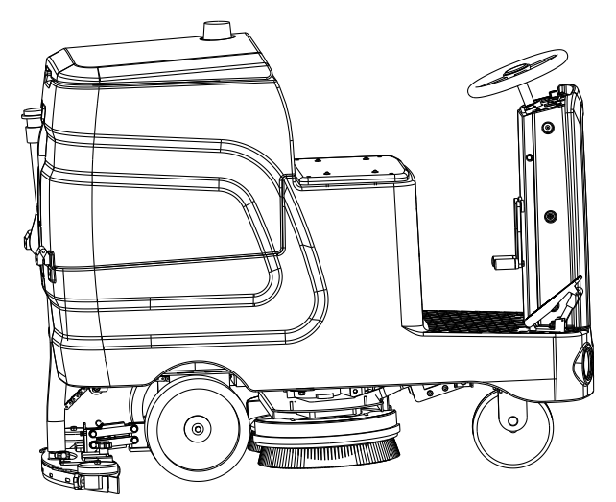

目录
Content

1. 电控箱组件ELECTRIC CABINET ASSEMBLY 3
2. 污水箱组件RECOVERY TANK ASSEMBLY 4
3. 清水箱组件SOLUTION TANK ASSEMBLY 5
4. 机头组件NOSE ASSEMBLY 7
5. 底座架组件FRAME ASSEMBLY 9
6. 扒头支架组件SUPPORT FRAME ASSEMBLY 10
7. 扒头组件SQUEEGEE ASSEMBLY 11

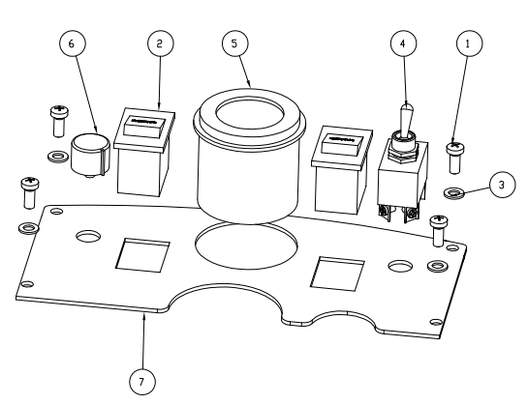

 | 零件编号 | 名称 | DESCRIPTION | 数量
1 | G010123 | 盘头十字螺钉M5*12 不锈钢 | Pan head Phillips screw M5*12 stainless steel | 4
2 | E010102 | 翘板开关 | Rocker switch | 2
3 | G010172 | 平垫圈Φ5*Φ10*1 不锈钢 | Flat washer Φ5*Φ10*1 stainless steel | 4
4 | E010142 | 前进后退开关 | Forward and back switch | 1
5 | E010130 | 电量显示表 24V | Battery indicator meter 24V | 1
6 | E010129 | 调速旋钮 | Speed control knob | 1
7 | A010145 | 显示面板2 | Display panel 2 | 1

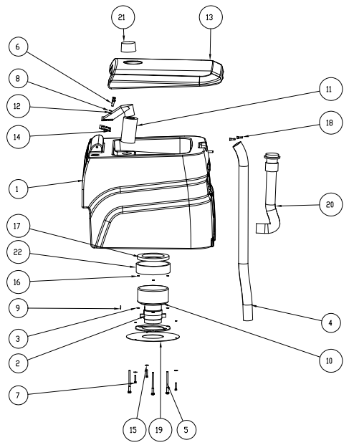

 | 零件编号 | 名称 | DESCRIPTION | 数量
1 | B010106 | 污水箱 560 | Sewage tank 560 | 1
2 | G010168 | 弹垫M5 不锈钢 | Elastic pad M5 stainless steel | 3
3 | G010175 | 平垫圈Φ6*Φ12*1 不锈钢 | Flat washer Φ6*Φ12*1 stainless steel | 3
4 | B010143 | 吸污管 Φ38*1000（01+06） | Suction tube Φ38*1000(01+06) | 1
5 | G010131 | 内六角圆柱头螺钉M6*16 不锈钢 | Allen cylindrical head screw M6*16 stainless steel | 3
6 | G010143 | M6-35外六角螺栓 | M6-35 Hex bolt | 2
7 | G010153 | 外六角M8*25 不锈钢 | Hexagon M8*25 stainless steel | 3
8 | G010174 | 平垫圈Φ5*Φ15*1.5 不锈钢 | Flat washer Φ5*Φ15*1.5 stainless steel | 2
9 | G010177 | 平垫圈Φ8*Φ16*1.5 不锈钢 | Flat washer Φ8*Φ16*1.5 stainless steel | 1
10 | E010109 | 吸水电机 24V 500W 两层旁管出风 | Suction motor 24V 500W two-layer side pipe outlet | 1
11 | B010153 | 吸污口球笼 | Suction spout ball cage | 1
12 | B010151 | 吸污口主体 | The main body of the suction port | 1
13 | B010107 | 污水箱盖 560 | Waste water tank cover 560 | 1
14 | B010152 | 吸污口密封垫 | Suction port gasket | 1
15 | G010172 | 平垫圈Φ5*Φ10*1 不锈钢 | Flat washer Φ5*Φ10*1 stainless steel | 3
16 | G010169 | 弹垫M6 不锈钢 | Elastic pad M6 stainless steel | 3
17 | B010175 | 吸水电机密封圈 Φ145*Φ90*10 | Water suction motor sealing ring Φ145*Φ90*10 | 1
18 | G010153 | M8*25外六角螺丝 | M8*25 hexagon screw | 2
19 | A010114 | 吸水电机盖板 | Water suction motor cover | 1
20 | B010139 | 排污管 Φ38*400（01+09） | Sewage pipe Φ38*400(01+09) | 1
21 | E010151 | 警示灯 24V | Warning light 24V | 1
22 | B010176 | 吸水电机消音棉 650*100 | Water absorbent motor silencer cotton 650*100 | 1

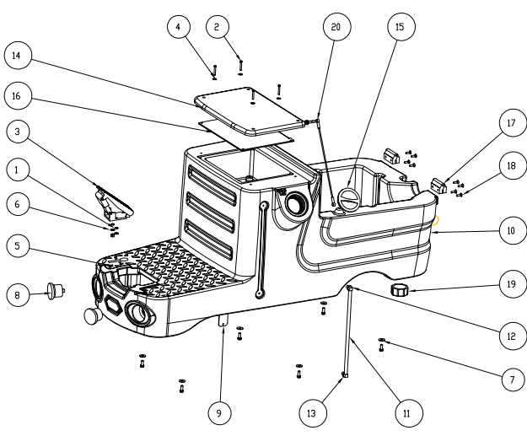

 | 零件编号 | 名称 | DESCRIPTION | 数量
1 | G010170 | 弹垫M8 不锈钢 | Elastic pad M8 stainless steel | 7
2 | G010125 | 盘头十字螺钉M5*25 不锈钢 | Pan head Phillips screw M5*25 stainless steel | 4
3 | E010161 | 油门踏板 24V | Accelerator pedal 24V | 1
4 | G010172 | 平垫圈Φ5*Φ10*1 不锈钢 | Flat washer Φ5*Φ10*1 stainless steel | 6
5 | G010107 | 自锁螺母M8 不锈钢 | Self-locking nut M8 stainless steel | 2
6 | G010177 | 平垫圈Φ8*Φ16*1.5 不锈钢 | Flat washer Φ8*Φ16*1.5 stainless steel | 2
7 | G010178 | 平垫圈Φ8*Φ24*2 不锈钢 | Flat washer Φ8*Φ24*2 stainless steel | 6
8 | E010145 | 圆灯2.5寸 24V | Round light 2.5 inch 24V | 2
9 | A010162 | 过滤器支架 | Filter holder | 1
10 | B010105 | 清水箱560 | Clear water tank 560 | 1
11 |  | 水位显示管Φ12* | Water level indicator Φ12* | 1
12 |  | 硅胶塞 | Silicone plugs | 2
13 | B010191 | 水位塑料弯头 Φ12 | Water level plastic elbow Φ12 | 2
14 | B010172 | 座垫 | Seat cushion | 1
15 | B010147 | 加水口盖 | Add water spout cap | 1
16 | A010150 | 座椅支撑板 | Seat support plates | 1
17 | B010181 | 塑料合页 65X65 | Plastic hinge 65X65 | 2
18 | G010114 | 沉头内六角M6*20 不锈钢 | Countersunk hexagonal M6*20 stainless steel | 8
19 | B010146 | 放水口盖 | Drain cap | 1
20 | C010131 | 水箱拉线600 | Tank cable 600 | 1

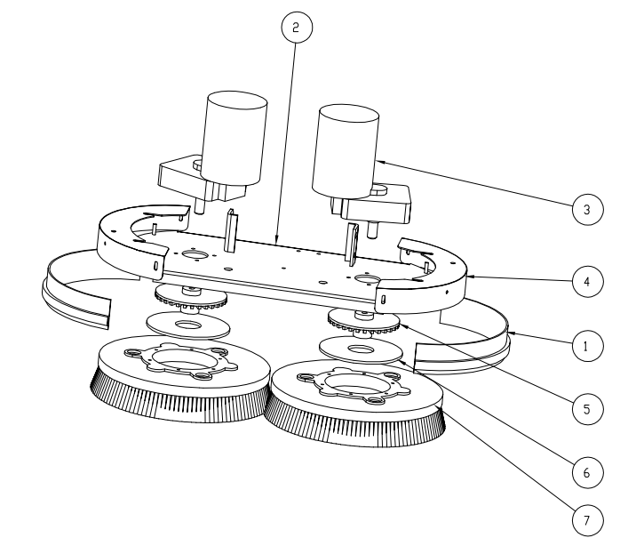
 | 零件编号 | 名称 | DESCRIPTION | 数量
1 | B010200 | 裙边 550mm | Skirt 550mm | 2
2 | A010190 | 电机安装板（双刷） | Motor mounting plate (double brush) | 1
3 | E010101 | 刷盘电机 24V 300W Φ18 | Brush plate motor 24V 300W Φ18 | 2
4 | A010160 | 刷盘外罩（双刷） | Brush disc cover (double brush) | 2
5 | C010135 | 磁吸刷盘扣 | Magnetic brush disc buckle | 2
6 | A010104 | 磁吸刷盘片 | Magnetic brush disc | 2
7 | B010137 | 磁吸刷盘 13寸 | Magnetic brush disc 13 inches | 2

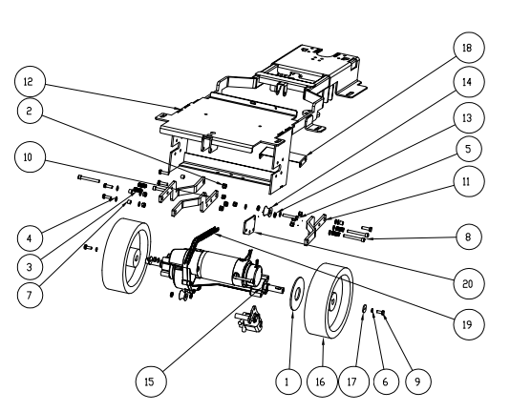

 | 零件编号 | 名称 | DESCRIPTION | 数量
1 |  | 刹车片 | Brake pads | 1
2 | G010107 | 自锁螺母M8 不锈钢 | Self-locking nut M8 stainless steel | 11
3 | C010142 | 压簧 Φ2XΦ12X55 | Pressure spring Φ2XΦ12X55 | 4
4 | G010177 | 平垫圈Φ8*Φ16*1.5 不锈钢 | Flat washer Φ8*Φ16*1.5 stainless steel | 15
5 | G010153 | 外六角M8*25 不锈钢 | Hexagon M8*25 stainless steel | 1
6 | G010170 | 弹垫M8 不锈钢 | Elastic pad M8 stainless steel | 3
7 | C010122 | 铜套 Φ8xΦ12x9 | Copper sleeve Φ8xΦ12x9 | 5
8 | G010136 | 内六角圆柱头螺钉M8*70 不锈钢 | Allen cylindrical head screw M8*70 stainless steel | 5
9 | G010152 | 外六角M8*20 不锈钢 | Hexagon M8*20 stainless steel | 3
10 | A010152 | 机头拉臂一 | Nose pull arm one | 1
11 | A010153 | 机头拉臂二 | Nose pull arm two | 2
12 | A010140 | 底座架 560 | Base frame 560 | 1
13 | G010195 | 轴承 688 zz | Bearing 688 zz | 4
14 | C010102 | 滑轮 Φ35 | Pulley Φ35 | 2
15 | E010115 | 驱动电机 24V 500W | Drive motor 24V 500W | 1
16 | B010157 | 驱动轮 Φ256*80 | Drive wheel Φ256*80 | 2
17 | G010176 | 平垫圈Φ8*Φ32*3 不锈钢 | Flat washer Φ8*Φ32*3 stainless steel | 2
18 | A010148 | 刷盘电机缓冲板 | Brush plate motor buffer plate | 1
19 |  | 链条 | chain | 1
20 | A010216 | 推杆支架 | Pusher bracket | 1

]

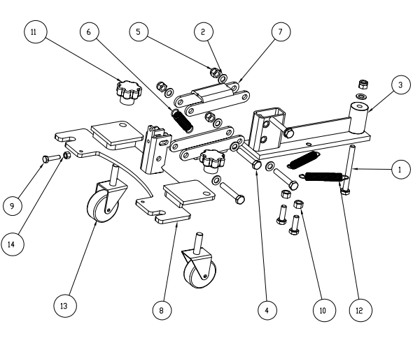

 | 零件编号 | 名称 | DESCRIPTION | 数量
1 | G010157 | 外六角M8*50半牙 不锈钢 | Hexagon M8*50 half stainless steel | 1
2 | G010177 | 平垫圈Φ8*Φ16*1.5 不锈钢 | Flat washer Φ8*Φ16*1.5 stainless steel | 9
3 | A010155 | 吸扒上支架 | Suck on the stand | 1
4 | G010153 | 外六角M8*25 不锈钢 | Hexagon M8*25 stainless steel | 4
5 | G010107 | 自锁螺母M8 不锈钢 | Self-locking nut M8 stainless steel | 5
6 | C010137 | 拉簧 Φ2XΦ13X60X34 | Pull spring Φ2XΦ13X60X34 | 1
7 | A010157 | 吸扒支架连接杆 | Suction bracket connecting rod | 2
8 | A010156 | 吸扒下支架 | Suction off the stand | 1
9 | G010143 | 外六角M6*35 不锈钢 | Hexagon M6*35 stainless steel | 1
10 | G010101 | 螺母M8 不锈钢 | Nut M8 stainless steel | 2
11 | B010195 | 胶木十字手柄 M10 | Bakelite cross handle M10 | 2
12 | C010144 | 拉簧 Φ1.5XΦ12X85X62 | Pull spring Φ1.5XΦ12X85X62 | 2
13 | B010220 | 万向轮 2寸丝杆 M10*40 | Universal wheel 2 inch lead screw M10*40 | 2
14 | G010100 | 螺母M6 不锈钢 | Nut M6 stainless steel | 1

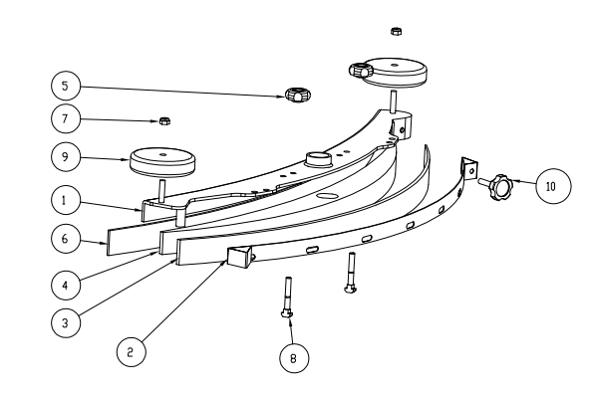
 | 零件编号 | 名称 | DESCRIPTION | 数量
1 | C010151 | 吸扒主体 1060 | Suction body 1060 | 1
2 |  | 吸扒钢条 1060 | Suction steel bar 1060 | 1
3 | B010190 | 后胶条 52*1160 | Rear strip 52*1160 | 1
4 | B010224 | 胶条压板 1060 | Strip press plate 1060 | 1
5 | B010194 | 胶木十字手柄 M8 | Bakelite cross-handle M8 | 2
6 | B010189 | 前胶条 52*1091 | Front strip 52*1091 | 1
7 | G010107 | 自锁螺母M8 不锈钢 | Self-locking nut M8 stainless steel | 2
8 | G010154 | 外六角M8*30 不锈钢 | Hexagon M8*30 stainless steel | 2
9 | B010196 | 防撞轮 Φ80*25 | Anti-collision wheel Φ80*25 | 2
10 |  | 七星胶木手柄 M8X40 | Seven-star bakelite handle M8X40 | 1

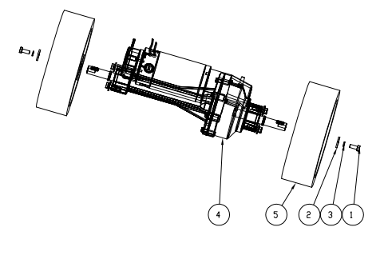

 | 零件编号 | 名称 | DESCRIPTION | 数量
1 | G010152 | 外六角M8*20 不锈钢 | Hexagon M8*20 stainless steel | 9
1 | G010152 | 外六角M8*20 不锈钢 | Hexagon M8*20 stainless steel | 9
2 | G010176 | 平垫圈Φ8*Φ32*3 不锈钢 | Flat washer Φ8*Φ32*3 stainless steel | 2
2 | G010176 | 平垫圈Φ8*Φ32*3 不锈钢 | Flat washer Φ8*Φ32*3 stainless steel | 2
3 | G010170 | 弹垫M8 不锈钢 | Elastic pad M8 stainless steel | 9
3 | G010170 | 弹垫M8 不锈钢 | Elastic pad M8 stainless steel | 9
4 | E010115 | 驱动电机 24V 500W | Drive motor 24V 500W | 1
4 | E010115 | 驱动电机 24V 500W | Drive motor 24V 500W | 1
5 | B010157 | 驱动轮 Φ256*80 | Drive wheel Φ256*80 | 2
5 | B010157 | 驱动轮 Φ256*80 | Drive wheel Φ256*80 | 2

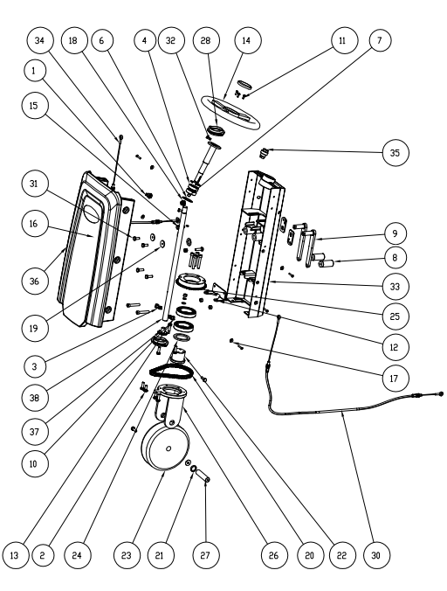

 | 零件编号 | 名称 | DESCRIPTION | 数量
1 | E010147 | 大灯开关 | Headlight switch | 1
2 | G010163 | 马车螺栓 M8*20 不锈钢 | Carriage bolt M8*20 stainless steel | 2
3 | G010177 | 平垫圈Φ8*Φ16*1.5 不锈钢 | Flat washer Φ8*Φ16*1.5 stainless steel | 6
4 | G010194 | 轴承 6010 2RS | Bearing 6010 2RS | 2
5 | G010199 | 万向节 Φ18*Φ32*85 | Universal joint Φ18*Φ32*85 | 1
6 | G010206 | 孔用弹性挡圈A | Hole with elastic retaining ring A | 2
7 | G010150 | 外六角M6*12 不锈钢 | Hexagon M6*12 stainless steel | 2
8 | C010118 | 提升把手 | Lift the handle | 2
9 | C010119 | 限位摇臂 | Limit rocker arm | 2
10 | G010170 | 弹垫M8 不锈钢 | Elastic pad M8 stainless steel | 4
11 | G010123 | 盘头十字螺钉M5*12 不锈钢 | Pan head Phillips screw M5*12 stainless steel | 3
12 | A010144 | 张紧支架 | Tension bracket | 1
13 | G010101 | 螺母M8 不锈钢 | Nut M8 stainless steel | 6
14 | B010170 | 方向盘 Φ265 | Steering wheel Φ265 | 1
15 | G010107 | 自锁螺母M8 不锈钢 | Self-locking nut M8 stainless steel | 2
16 | G010125 | 盘头十字螺钉M5*25 不锈钢 | Pan head Phillips screw M5*25 stainless steel | 6
17 | G010172 | 平垫圈Φ5*Φ10*1 不锈钢 | Flat washer Φ5*Φ10*1 stainless steel | 6
18 | E010148 | 喇叭开关 | Horn switch | 1
19 | G010176 | 平垫圈Φ8*Φ32*3 不锈钢 | Flat washer Φ8*Φ32*3 stainless steel | 2
20 |  | 链条 | chain | 1
21 | C010106 | 前轮轴套 | Front wheel bushings | 2
22 | B010159 | 轴承轮 Φ200*60 | Bearing wheel Φ200*60 | 1
23 | B010156 | 前驱轮 | Front wheel drive wheels | 1
24 | A010159 | 垫圈 | washer | 1
25 | C010105 | 链轮 | Sprocket | 1
26 | A010158 | 前轮安装支架 | Front wheel mounting brackets | 1
27 | C010107 | 轮轴 | axle | 1
28 | G010196 | 轴承 PFL205/SB205 | Bearing PFL205/SB205 | 2
29 |  | 链条 | chain | 1
30 | C010131 | 拉线 | Cable | 1
31 | G010152 | 外六角M8*20 不锈钢 | Hexagon M8*20 stainless steel | 2
32 | C010117 | 前转向转轴 | Front steering hinge | 1
33 | A010141 | 转向架 560 | Bogie 560 | 1
34 |  | 拉线2 | Pull wire 2 | 1
35 | E010134 | 钥匙开关（双触点） | Key switch (dual contact) | 1
36 | B010108 | 转向罩 560 | Steering hood 560 | 1
37 | C010105 | 链轮 | Sprocket | 1
38 | C010104 | 方向轴 | Direction axis | 1

