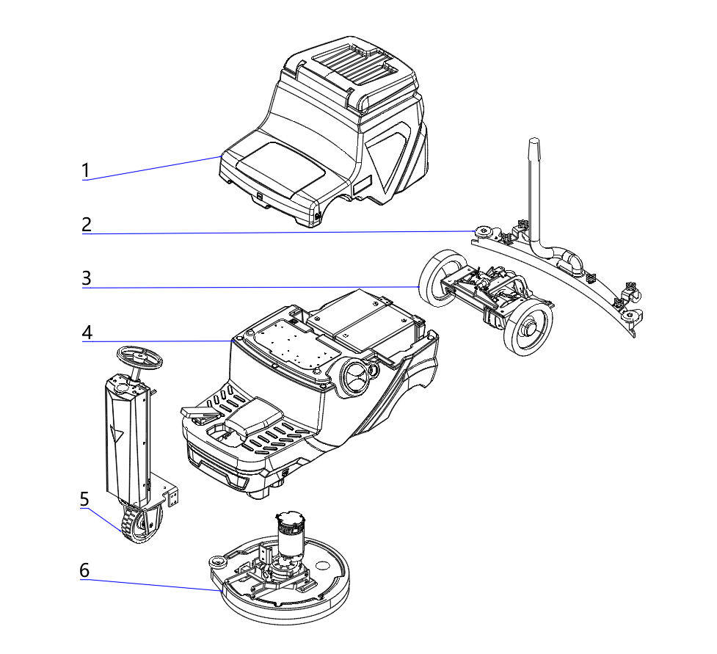

No. | Name
1 | Recovery tank parts
2 | Squeegee parts
3 | Chassis parts
4 | Solution tank parts
5 | Nose parts
6 | Brush plate parts

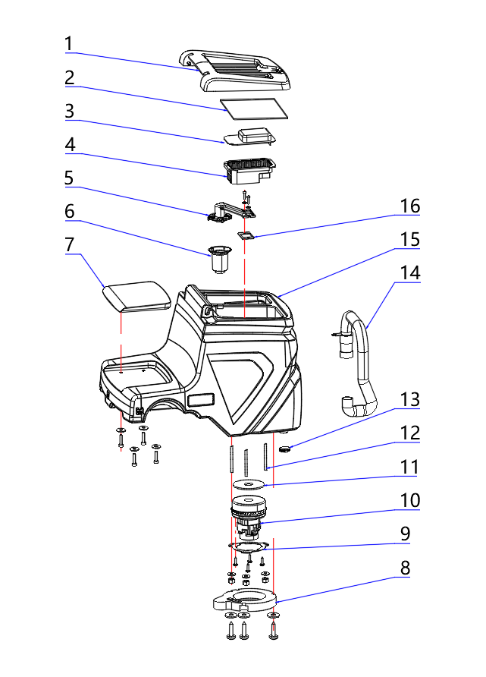

- Recovery tank parts
No. | Code | Name | Specification | Number
1 | X6B00-34001 | Recovery tank cover | K68 Chancee yellow | 1
2 | X74A0-09011 | Sealing strip |  | 1
3 | X03Z0-22211 | 21036 sewage basket cover | Orange | 1
4 | X03Z0-22201 | 21035 sewage basket cover | Orange 210*140*70mm | 1
5 | X13A0-09031 | Float ball cage bracket | Black | 1
6 | X13A0-09021 | Float ball cage | Double-ball 135mm*φ67 | 1
7 | X16Z0-36001 | Cushion | Exclusive to K69 | 1
8 | X11Z0-33031 | Suction motor cover | Wall thickness 3mm | 1
9 | X19A0-02001 | Suction motor fixing plate | Waist-type hole sheet metal | 1
10 | X11Z0-02091 | XDS suction motor AD30-229 |  | 1
11 | X13A0-09131 | Motor pad | Black φ150*φ55*T=10mm | 1
12 | X13A0-09291 | Screw | M6*100mm | 3
13 | X13A0-09431 | Hoseclamp | Cross head 21-57 | 1
14 | X11Z0-39101 | Sewage draining tube assembly | For K68 | 1
15 | X11Z0-33021 | Recovery tank | Wall thickness 6.5 | 1
16 | X13A0-09041 | Bracket sealing pad | Black 95*50*3mm | 1

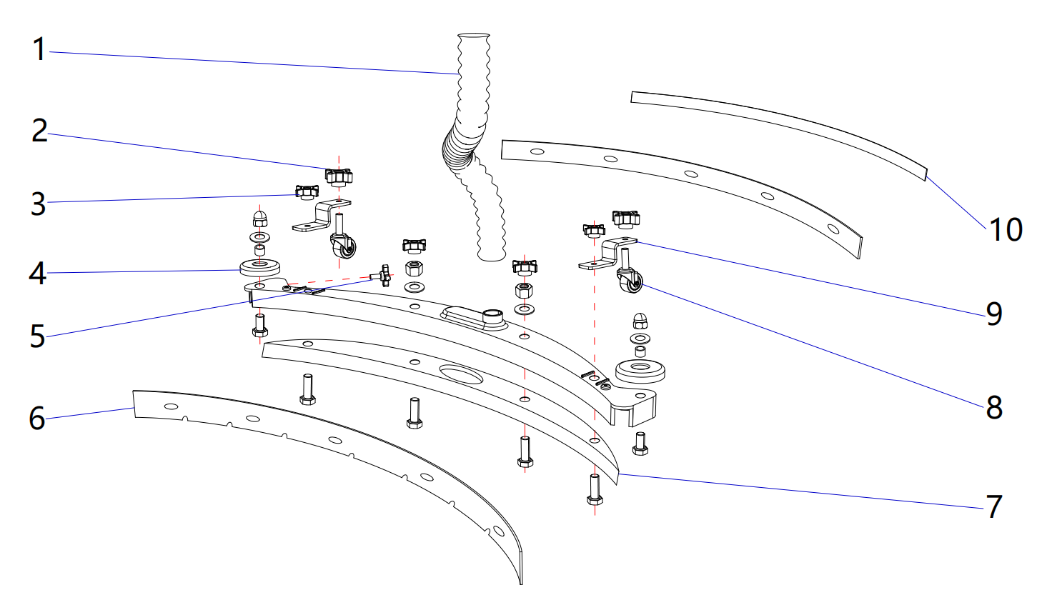

- Squeegee parts
No. | Code | Name | Specification | Number
1 | X11Z0-39111 | Sewage suction tube assembly | For K68 | 1
2 | X13A0-49071 | Black cross nut | M10 through hole | 2
3 | X20A0-09011 | Orange cross knob | Orange M8 through hole | 4
4 | X20A0-49011 | Squeegee anti-collision wheel | Orange φ77*20mm through hole φ12.5 | 2
5 | X13A0-49081 | Black cross screw | M8*45mm | 1
6 | X13A0-49021 | Rubber strip | Red Small and delicate 800mm | 1
7 | X13A0-49051 | Squeegee plastic inner gear | Black injection moulding | 1
8 | X13A0-49011 | Squeegee head small wheel | Mecanum wheel φ50*20mm | 2
9 | X13A0-02031 | Fixing plate of squeegee head small wheel | Z-type T=5mm Black spraying moulding | 2
10 | X13A0-49061 | Squeegee pressure strip | 820*30*1mm | 1

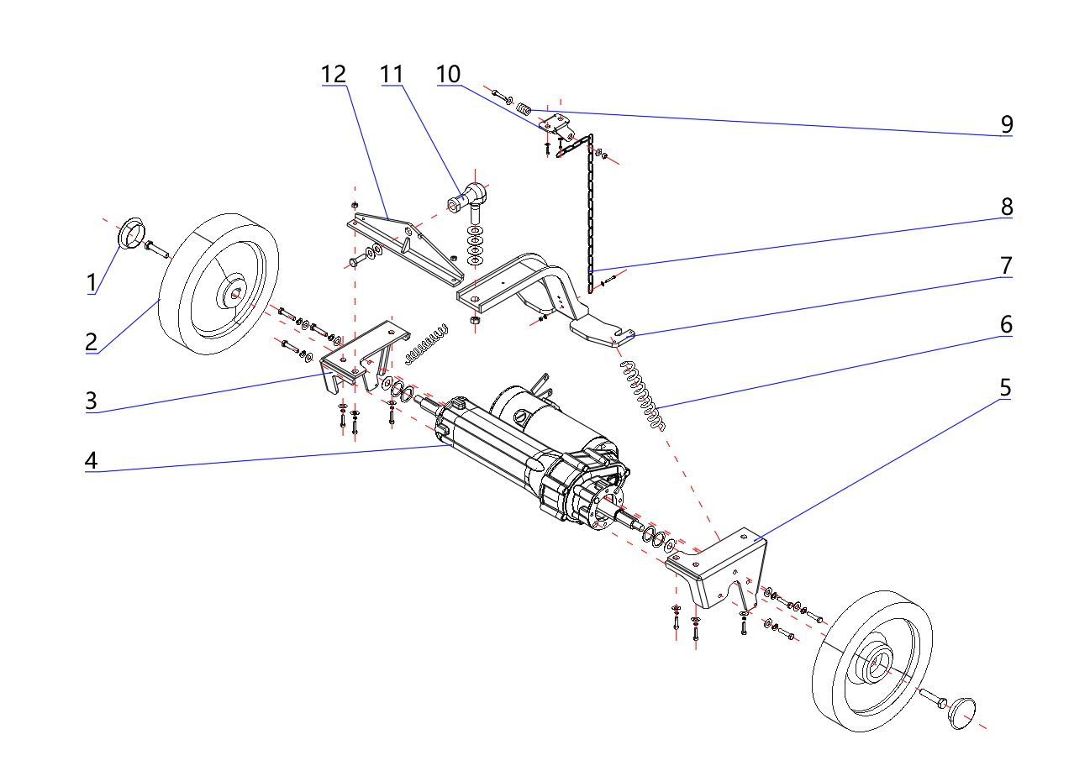
- Chassis parts
No. | Code | Name | Specification | Number
1 | X11Z0-34051 | Wheel hub cover | Orange | 2
2 | X11Z0-34011 | Plastic injection wheel (driven) | For K68 | 2
3 | X11Z0-32401 | Rear wheel bracket |  | 1
4 | X65A1-02011 | Driving axle (Huilong) | C01B-9716-500-24-3000（X5/X6 type） | 1
5 | X11Z0-32411 | Rear wheel bracket 2 |  | 1
6 | X11Z0-39061 | Return spring | Length: 110, Wire diameter 1.8 | 2
7 | X11Z0-32391 | Squeegee bracket(Aluminum) |  | 1
8 | X65A0-09291 | Iron chain ring | Wire diameter 3 240mm | 1
9 | Z0608-00001 | Bearing | 608 bearing | 4
10 | X16Z0-32361 | Squeegee hanger | Used on hot selling small ride-on machine | 1
11 | X65A0-09271 | Ball head bolt | M14 Outer wire to M14 Inner wire | 1
12 | X11Z0-32441 | Ball joint installation plate |  | 1
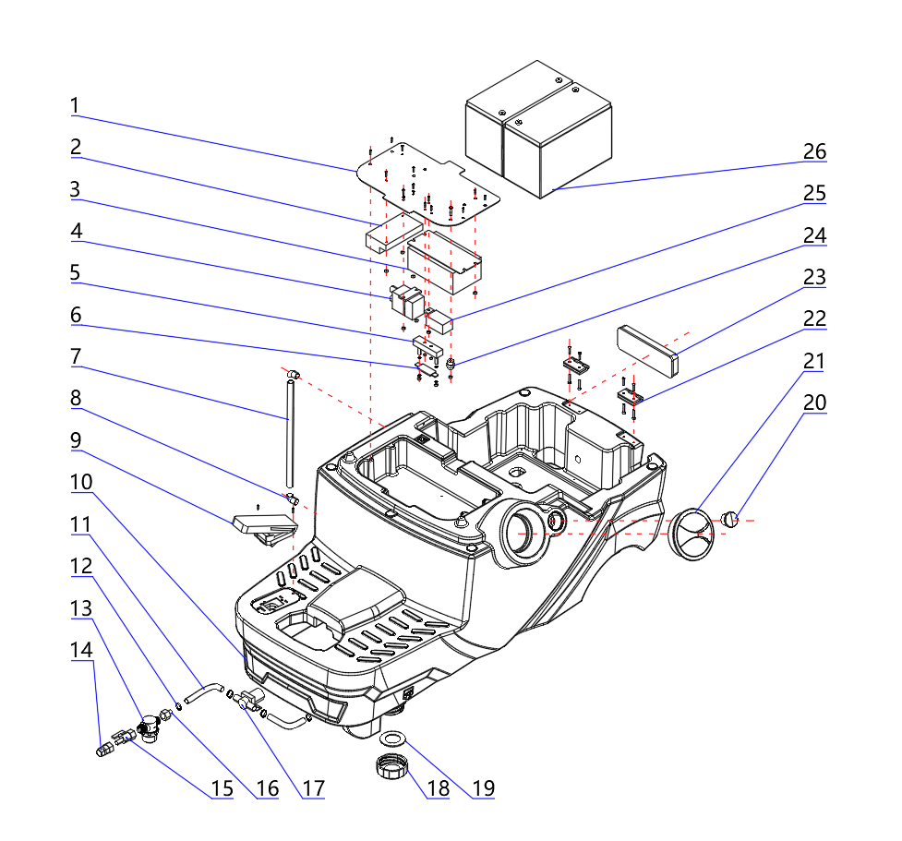

- Solution tank parts
No. | Code | Name | Specification | Number
1 | X11Z0-32491 | Electrical installation plate |  | 1
2 | X11Z0-02121 | Controller | 140-24V（Hot-selling small ride-on machine） | 1
3 | X11Z0-05041 | Built-in charger | K68（for hot-selling small ride-on machine） | 1
4 | X09X1-05021 | Contactor | Sanu-tech 80A | 1
5 | X13A1-06051 | Fuse base | Double-end 85*20mm | 1
6 | X49A1-06011 | Fuse | Fork bolt fuse 80A | 1
7 | X65A0-09121 | Water level tube | Inner diameter of transparent hose: φ8*410mm | 1
8 | X09X0-09051 | L-shaped plastic joint | 8mm-8mm | 2
9 | X0A31-05001 | Pedal accelerator | K80 | 1
10 | X11Z0-33011 | Solution tank | Hot-selling small ride-on machine（Chancee’s color） | 1
11 | X65A0-09141 | Steel wire hose | Inner diameter φ8*260mm | 1
12 | X13A0-09151 | hoseclamp | Cross head 9-16 | 4
13 | X31A0-09081 | Clean water filter | Black Double-end G½ Straight outer wire | 1
14 | X11Z0-39201 | Flexible joint 2 (1/2 inch inside and outside) | 1/2 inch inner and outer wire union Length: 31mm | 1
15 | X11Z0-09551 | Draining valve | Outer wire G½ Inner wire G½ | 1
16 | X11Z0-09571 | Inner wire pagoda-shape straight joint | G½ Inner wire to φ12 | 1
17 | X31A1-05051 | Solenoid valve | DC 24V 0-0.005MPa | 1
18 | X03Z0-22261 | 21038 Water draining cover | PPT20，Orange | 1
19 | X09X0-09251 | Sealing pad of water draining cover | M52 | 1
20 | X11Z0-26001 | Rubber plug of water inlet port | Silicone，D52-d46.3-H15.5 | 1
21 | X65A0-09071 | Solution tank cover | Black Half external screw thread φ120 | 1
22 | X47A0-09021 | Hinge | Hole spacing: 36*36 Via hole M6 Thickness: 6mm | 2
23 | X74A1-05001 | Tail light | Multifunctional explosion anti-fog lamp 24V | 1
24 | X11Z0-02111 | Insulator M8*30 | M8（with screw M8*30） | 1
25 | X11Z0-05031 | Relay（JD2912-1Z-24V 80A) | JD2912-1Z-24V 80A | 1
26 | X16A1-03001 | Battery | Tianneng maintenance free 6-EVF/103Ah | 2

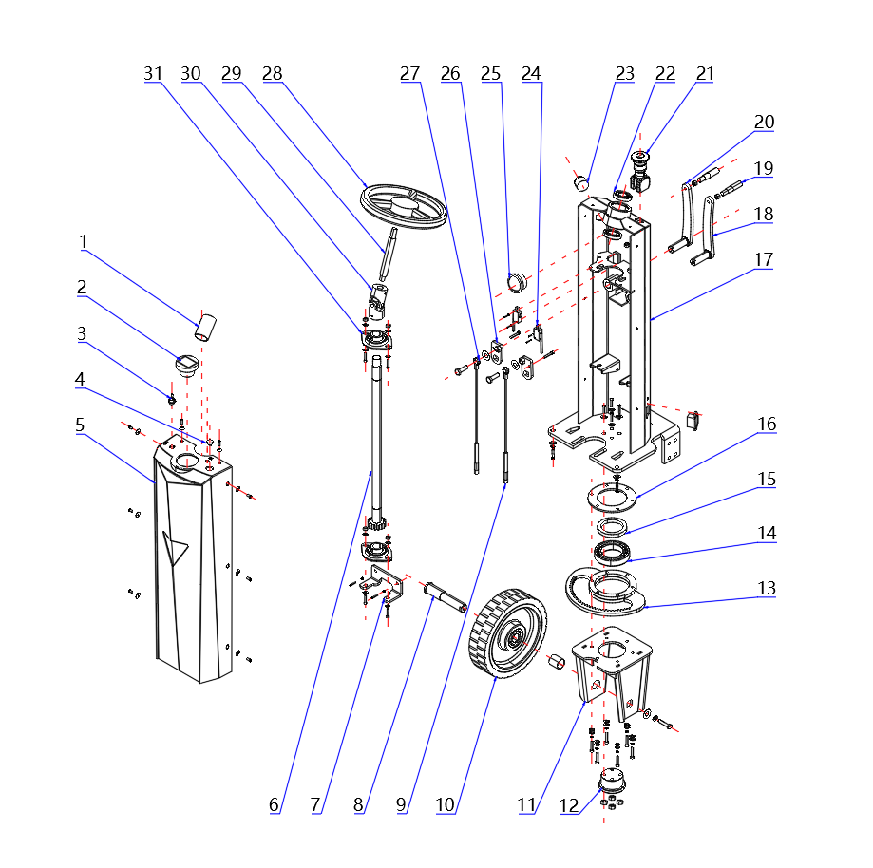

- Nose Parts
No. | Code | Name | Specification | Number
1 | X65A0-09151 | Dust cover | Black φ57*φ49*70mm | 1
2 | X20A1-05001 | Power meter | Round 24V Input | 1
3 | X35A1-05031 | Three-claw switch | Three pins and two gears 15A 250V | 1
4 | X11Z0-02011 | Horn switch | φ16 Mushroom Head Green Metal Button | 1
5 | X11Z0-34021 | Head cover | For K68 | 1
6 | X16Z0-30601 | Lower steering shaft assembly |  | 1
7 | X16Z0-32311 | Trundle adjustment plate |  | 1
8 | X11Z0-32351 | Wheel axle |  | 1
9 | X11Z0-39091 | Squeegee cable assembly | For K68 | 1
10 | X65A0-09171 | Front wheel | φ200*60mm Using 6204 bearing（X5/X6 type） | 1
11 | X11Z0-30501 | Front wheel supporting assembly |  | 1
12 | X65A0-62081 | Four-hole short shaft | For X5 | 1
13 | X11Z0-30401 | Gear plate assembly |  | 1
14 | Z6010-00001 | Bearing | 6010 | 1
15 | X65A0-62051 | Front wheel bracket washer |  | 1
16 | X65A0-02131 | Driving iron plate |  | 1
17 | X16Z0-10011 | Front under-frame welding assembly |  | 1
18 | X16Z0-30401 | Rocker arm assembly (left) |  | 1
19 | X16Z0-09211 | Rocker handle | Black M8x50 | 2
20 | X16Z0-30301 | Rocker arm assembly (right) |  | 1
21 | X65A1-05001 | Emergency stop switch | ANIUDY LA158-BE102 | 1
22 | 6004R-00001 | Bearing | 6004RS | 2
23 | X31A1-05031 | Power lock | ANIUDY LA158-BE101 | 1
24 | X11Z0-02031 | Microswitch (AV-163-1C25) | AV-163-1C25 | 2
25 | X65A1-05011 | Horn | Black 24V | 1
26 | X11Z0-32421 | Rocker arm plate |  | 2
27 | X11Z0-39081 | Brush plate cable assembly | For K68 | 1
28 | X16Z0-09201 | Steering wheel | 300mm，36 gears | 1
29 | X16Z0-32091 | Upper direction axis |  | 1
30 | X16Z0-69001 | Universal joint | 36 gears | 1
31 | PFL204-00001 | Bearing | PFL204 bearing | 2

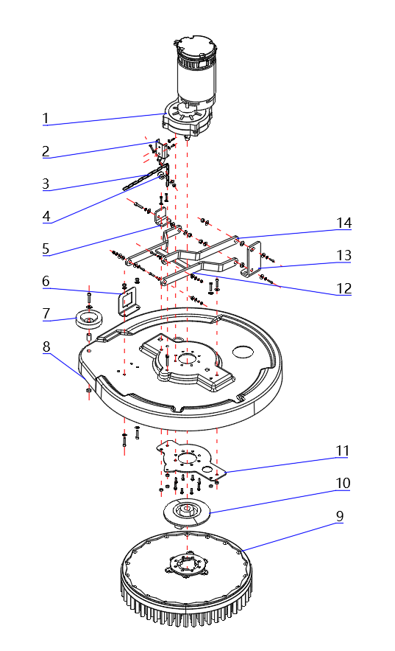
- Brush plate parts
No. |  | Code |  | Name | Specification |  | Number
1 | X20A1-02011 |  | Brush motor |  |  | Threaded 24V/500W HC113PA09 Central water outlet |  | 1
2 | X11Z0-30801 |  | Brush plate lifting bracket assembly |  |  |  |  | 1
3 | X65A0-09291 |  | Iron chain ring |  |  | Wire diameter 3 240mm |  | 1
4 | 6000R-00001 |  | Rolling wheel bearing |  |  | 6000RS |  | 1
5 | X11Z0-32261 |  | Brush plate cover connection bracket 2 |  |  |  |  | 1
6 | X11Z0-32291 |  | Installation plate for solenoid valve |  |  |  |  | 1
7 | X20A0-49011 |  | Squeegee anti-collision wheel |  |  | Orange φ77*20mm Through hole φ12.5 |  | 1
8 | X11Z0-34001 |  | Brush plate cover |  |  | For K68 |  | 1
9 | X11Z0-39001 |  | 70cm brush plate |  |  | Orange brush hair(175 plastic brush plate buckle) |  | 1
10 | X13A0-34031 |  | Plastic key pin flange buckle |  |  |  |  | 1
11 | X11Z0-39001 |  | 70cm brush plate |  |  | Orange brush hair(175 plastic brush plate buckle) |  | 1
12 | X11Z0-30701 |  | Lower connecting rod assembly of brush plate |  |  |  |  | 1
13 | X11Z0-32251 |  | Brush plate cover connection bracket |  |  |  |  | 1
14 | X11Z0-32231 |  | Brush plate connecting rod 3 |  |  |  |  | 1

